Cloughduv National School
Review of 2018 / 2019

Dear Families,
Here we are at the end of another school year....it has just flown by!
A successful school is only successful because of the dedicated members of the team.
So it is important to thank all the staff who work so hard and support me in the day-to-day workings of the school.
Secondly, a word of thanks to the Parents Association who have done so much for all the children this year.
Finally, a special appreciation goes out to the members of the Board of Management who are the backbone of all the big decisions taken in relation to the school.
To all those mentioned, I say a big THANK YOU!!
The children in Cloughduv NS have had a great year, enjoying lots of sporting activities, music, drama and art as well as a big focus on environmental matters with our Green Flag work and health and wellness with our Health Promotion Flag activities.
Below you will see a summary of the whole school year.
Wishing you all a wonderful, sunny Summer break!
Sylvia Linehan, (PRINCIPAL)

Junior Infants: We welcomed our new junior infants – Nina, Colm, Sam, Emily, Callum, Ryan, Ella, Leo, Emily Rose, Daniel, Fintan and Nathan into our school community last September! Last week, the new junior infants who will be starting with us in September 2019 came to visit and meet their teacher, Ms. Purcell.
Lots of Learning: We have been hard at work during the year learning lots of new things and developing new skills. These are some of the highlights: 5th & 6th classes completed marvellous projects using recycled materials; 4th and 5th had a Kindness Challenge running in their classroom; 2nd and 3rd planted potatoes; 1st and 2nd planted some vegetables and flowers; Juniors and Seniors performed a showcase of poems and songs for parents;
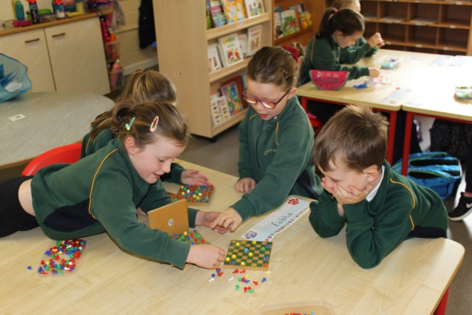
Tree Day: On Thursday, October 4th, to celebrate National Tree Day every class went for a nature walk in Ryecourt. 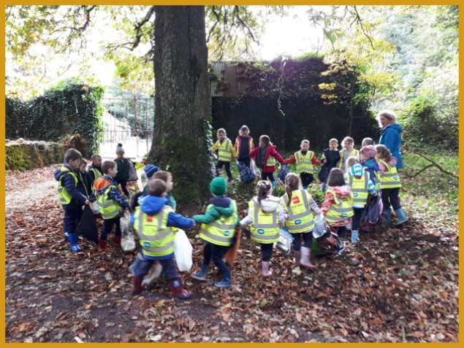
Hallowe’en: Pupils had great fun dressing up for Hallowe’en. They watched a movie, enjoyed popcorn and had a dance party!
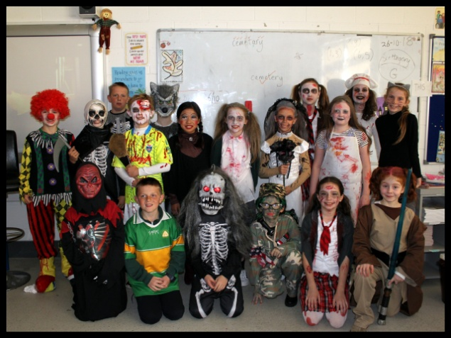
Speech & Drama: Donna O’ Keeney taught speech & drama classes for 10 weeks in Spring 2019 in every class.
Christmas Performance: On Wednesday, 12th December, we had a marvellous night of festive entertainment in the church with all classes taking part.
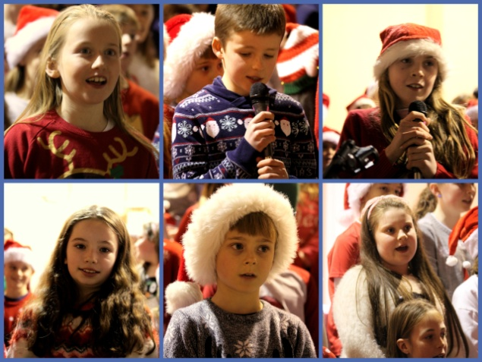
World Book Day: We celebrated World Book Day in March by dressing up as our favourite character from a book and we brought some of our favourite books to school. It was great fun!
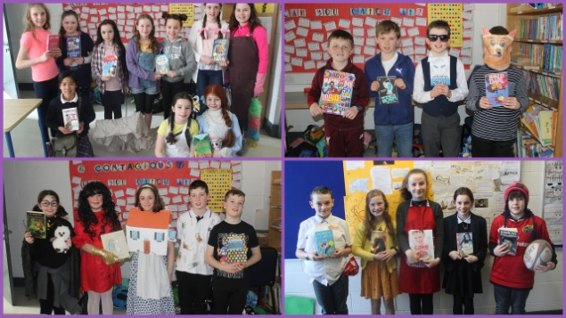
Eason Spelling Bee: Harry Murphy, 6th Class represented the school in the county finals of the Eason Spelling Bee in Christian Brothers College, Cork on 13th March.

Credit Union Quiz: A primary school’s quiz organised by the Credit Union was held in The Castle Hotel, Macroom at the end of January. Cloughduv N.S. was represented by two teams on the day, and while they were not among the prize winners on this occasion, they performed very well.
GAA: Our GAA year commenced in early September with the Sciath na Scol football competition. Our team had a good campaign this year and reached the semi final following victories over Kilbonane, Coolea and Gaelscoil Dhroichead na Bandan! Unfortunately we were beaten by a better team in Firmount in the semi final. In Spring 2019, we commenced training teams for the Sciath na Scol hurling and camogie matches. Again, our team performed really well reaching the semi finals before losing out to Castlemartyr and Clonpriest. Special thanks to Mr. McElroy and Mr. Verling for their hard work in preparing the teams.
Training and skills development has also been happening throughout the year. Junior Infants, Senior Infants and 1st Class have been learning basic hurling skills. And our local Garda James Masters gave a few sessions coaching football skills. We also had members of Kilmurray GAA provide coaching sessions in football to some class groups. The future certainly looks bright!
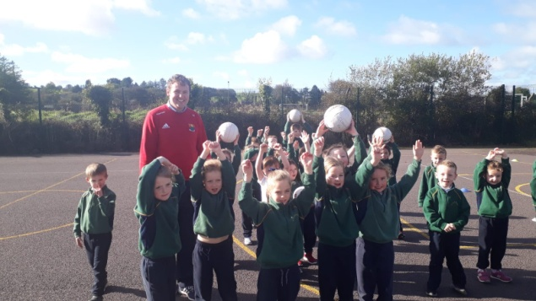
Rugby: Coaching in rugby continued in the school in association with Bandon RFC during the past year. Brandon, a rugby coach from New Zealand visited the school each Friday for a coaching session. A number of classes benefitted from this initiative and subsequently took part in a blitz in Bandon RFC.
Green Schools: On Friday, 7th June, we celebrated our second Green Flag with an action packed ‘green themed’ day! We began the day with an environmental themed fancy dress parade! Then we had a flag raising ceremony at the front of the school. And finally a singing performance in the halla and some home baked treats for everyone to celebrate a great achievement. A special word of thanks to Mrs. Landers for all her work in helping our school achieve this flag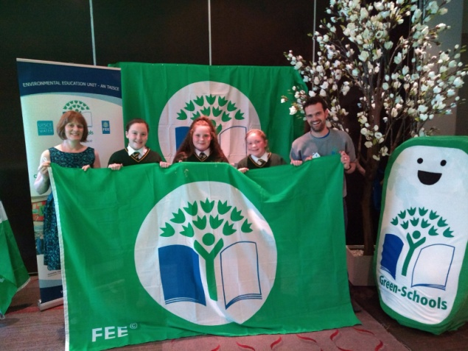

Cork City Sports: This event took place on Thursday, 30th May in C.I.T. Our school was very well represented by a team of boys and girls who ran in the individual races from U-6 up to U-13 and we also had 2 boys relay teams and two girls relay teams. Well done to all who represented our school so well and special congratulations to the prize winners on the day.
Well done also to all the Cloughduv athletes who represented the school so well in Macroom in October at the cross country athletics event. We had a number of prize winners on the day! 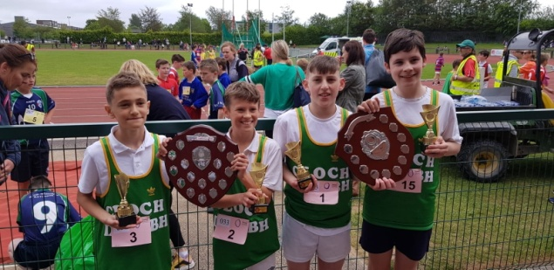
Swimming: Five swimming lessons took place in Leisureworld for all pupils from 1st – 4th class during May and June.
Health Promotion: We had a week of health promotion in late May. We raised the Health Promoting School Flag; Caroline Robinson, a local organic farmer came to visit and talked to us about growing vegetables and showed us lots of her produce; We tried lots of healthy lunch alternatives thanks to the parents association; We had a cooking demonstration from Mags Guilfoyle and some of the classes enjoyed making pesto, hummus and smoothies! Special thanks to Ms. Purcell for all her hard work in this area.
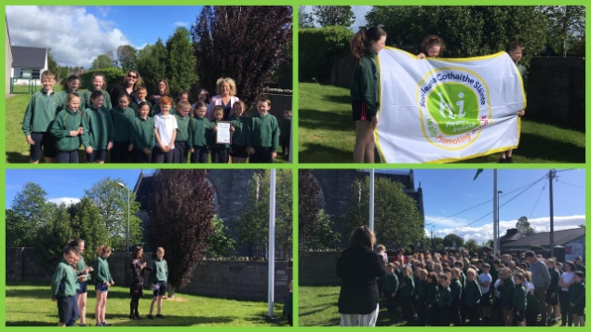
Music and Singing Workshops: In January, two percussionists Alex Petcu and Catriona Frost treated the children to a wonderful musical performance in the hall. Then in February, the children enjoyed a hands on drumming workshop with Patrick Naughton. In April, the children in Junior Infants, Senior Infants and 1st Class took part in Cór Fhéile na Sco in City Hall. In May, the children enjoyed a singing workshop with Peter Stobart, the head of music in St. Finbarr’s Cathedral. 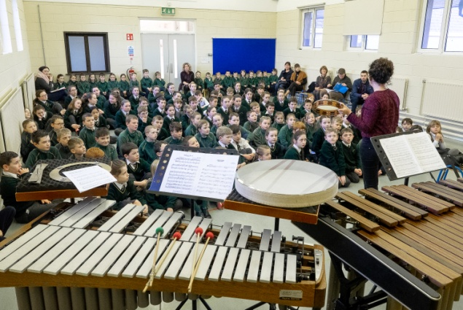
Theatre Performance: On Tuesday, 4th June, all the children were treated to a wonderful theatre performance here in school called “The Bluebird” by a live theatre company. It was a fantastic end of year treat for everyone.
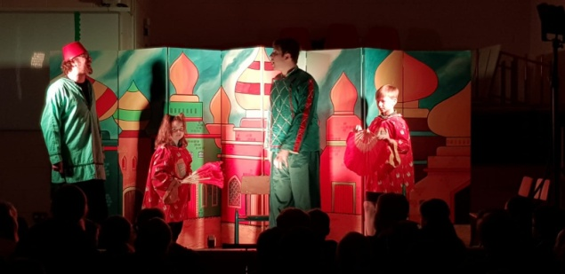
First Holy Communion: The children in 2nd class received their First Holy Communion on Saturday, 25th May in St. Joseph’s Church, Cloughduv.

School Tours 2019:
- Junior Infants & Senior Infants: Rumley’s Farm on Wednesday, 12th June.
- 1st, 2ndClass & 3rd Class: West Cork Secret on Tuesday, 25th June.
- 4th & 5th Class: Spike Island, on Wednesday, 5th June
- 5th & 6th Class: Ballyhass on Wednesday, 5th June
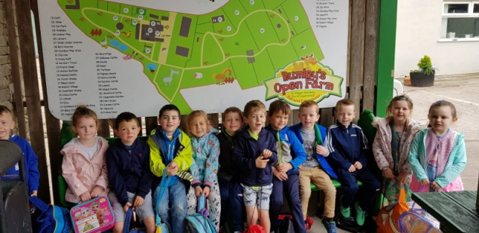

Graduation Ceremony: A graduation ceremony for 6th class pupils took place on Wednesday, 19th June.

Parents Association: Thanks to the Parents Association, Chairperson Shirley Bateman and Eileen Browne and Caitriona Crowley, for all their work and fundraising, throughout the year. They organised two clothes collections, Halloween movies and popcorn, school calendars, a wonderful week of Seachtain na Gaeilge activities and an American Tea Party. They organised Santa’s visit to school, an Easter Egg hunt for all pupils, food tasting during healthy eating week and also food for some occasions throughout the year as well as a fantastic sports fun day in June.
Website & Blog: We encourage you all to visit our school website and blog. Both are updated with photographs and news regularly! Check them out here: www.cloughduvns.ie
https://cloughduvns.edublogs.org
New Email Address: Our new address from 29th August 2019 will be: cloughduvnationalschool@gmail.com
Reopening: The school will reopen for all pupils on Thursday, 29th August. The calendar of holidays and closures for the school year 2018 – 2019 is online on both our website and blog.
WOW! What a busy year it has been!
